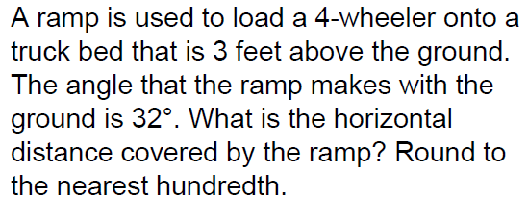
Problem Solving
STATION # 1

Problem Solving
STATION # 2
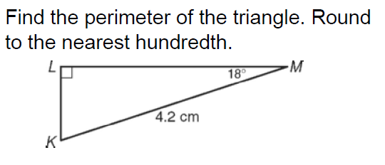

Problem Solving
STATION # 3
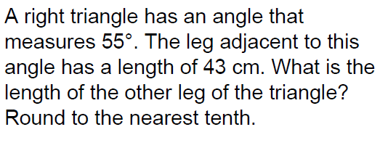

Problem Solving
STATION # 4
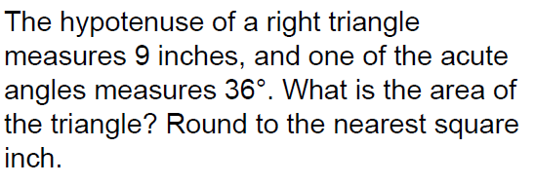

Problem Solving
STATION # 5
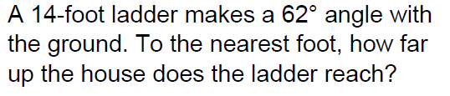

Problem Solving
STATION # 6
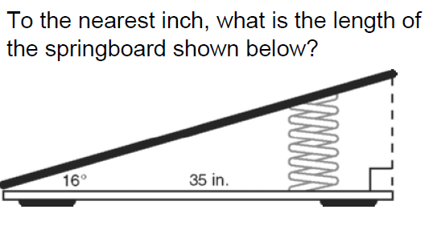

Problem Solving
STATION # 7
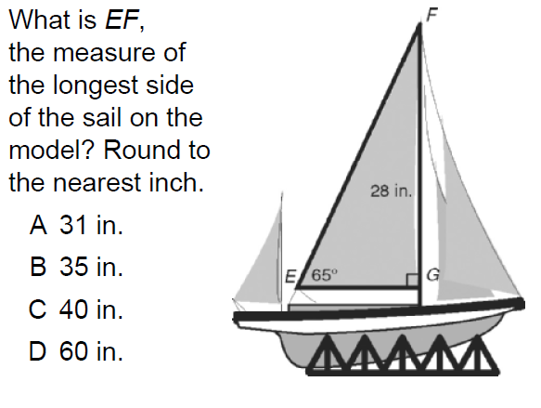

Problem Solving
STATION # 8
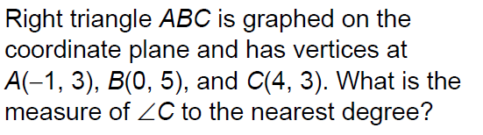
Problem Solving
STATION # 9

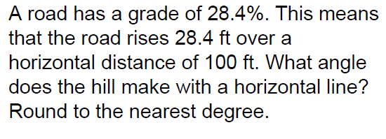

Problem Solving
STATION # 10
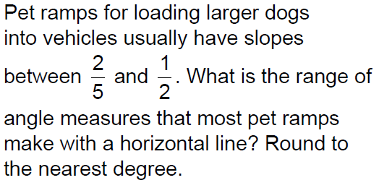

Problem Solving
STATION # 11

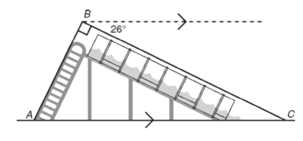

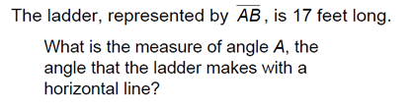

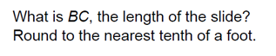

Problem Solving
STATION # 12

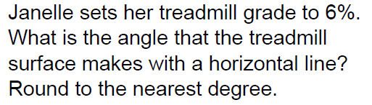

Problem Solving
STATION # 13
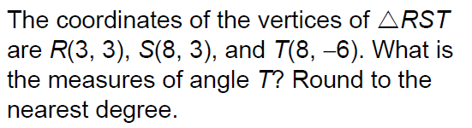

Problem Solving
STATION # 14
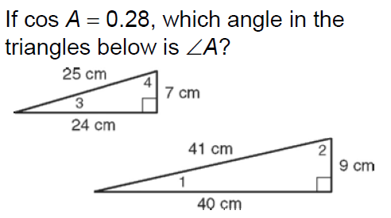

Problem Solving
STATION # 15
